CPR Broker
PART standard

Contents
CPR Broker 1
PART standard 1
1 Overview 3
2 Operations 4
2.1 Read 4
2.2 List 4
2.3 Search 5
3 Registrations and impact periods 6
4 Attributes, states and relationships 6
5 Events 6

Overview
This document describes a high level overview of the proposed solution. The main target of this document is to ensure a correct understanding of the project’s requirements.
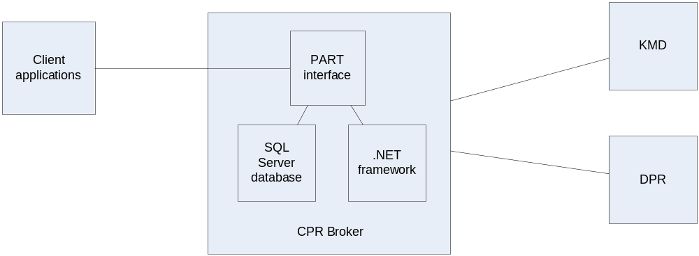
The proposed solution is to convert CPR Broker into a system that allows data exchange of persons’ data in standard PART format.

Operations
As described in the specification document, the operations are all about person data. Supported operations only include reading and searching. This is because of the nature of the broker, which is only targeted to simplify data reads.

Read
The read operation is limited to persons that have been previously loaded onto the system by means of calling Search.
The following diagram shows an overview of the process.
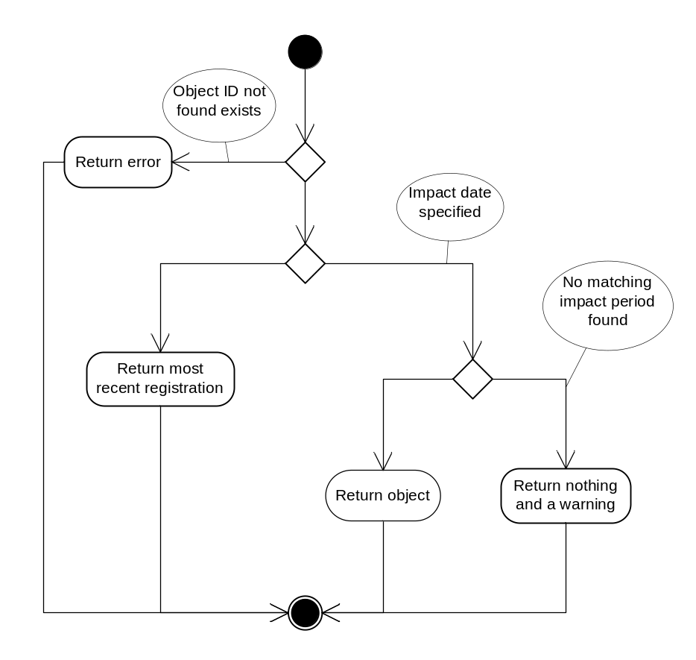

List
Similar to Read, but acts on a list of ID’s instead of a single ID.

Search
This process is where the major work is. The original implementation of CPR broker can be viewed as a simple implementation of Search operation. Actually; it is an implementation that is limited to search by CPR number.
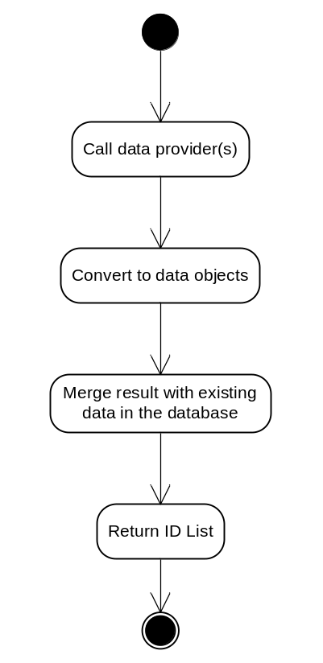

Merge
Since this is an important step in the process. When getting new data from data providers (such as DPR), it is important to correctly merge it with the database. This involves management of registrations and impact periods. A new set of data will generally be a new registration.

Registrations and impact periods
The concept of registrations will be incorporated in the solution. Each data update will be considered a registration (if needed). Registrations and impact periods should replace history tables that provide a similar functionality.

Attributes, states and relationships
They will be adjusted to match the new PART structure. They will be part or registrations, and will have impact periods attached to them.

Events
Events in general will remain similar to what they are now. However, they will be adjusted to match the new data structures.
The notification channels will remain the same as current. This means XML file, Web service & GPAC channels.

